 | Socialist republic of Vietnam  Independence - Freedom - Happiness  _________________ | No. 14
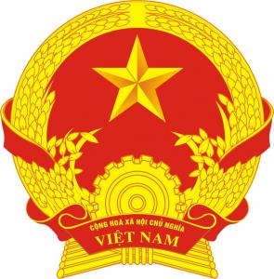

Certificate of marriage

Surname, middle name, given name of Wife:  NGUYEN THI THUY | Surname, middle name, given name of Husband:  HO SY TRONG
Date of birth : 03/06/2003 | Date of birth : 20/10/1994
Ethnic group : Kinh  Nationality: Vietnamese | Ethnic group : Kinh  Nationality: Vietnamese
Residence address: Tho Thanh Commune, Yen Thanh District, Nghe An Province | Residence address: Tho Thanh Commune, Yen Thanh District, Nghe An Province
Identification documents: Citizen ID No. 040303007220 issued by the Police Department for Administrative Management of Social Order on 19/04/2021 | Identification documents: Citizen ID No. 040094022524 issued by the Police Department for Administrative Management of Social Order on 09/08/2021

Registration place: People's Committee of Tho Thanh Commune, Yen Thanh District, Nghe An Province
Date of registration: 07/02/2023

Wife  (Signed)  Nguyen Thi Thuy | Husband  (Signed)  Ho Sy Trong

SIGNATORY OF MARRIAGE CERTIFICATE
VICE-CHAIRMAN
(Signed and sealed)
Nguyen Thi Thuy

NOTES ON ADJUSTMENT OF CONTENTS IN THE CERTIFICATE OF MARRIAGE

No | Date of adjustment | Adjusted contents  (Stamp on noted contents) | Basis for adjustment | Full name, signature of adjuster

